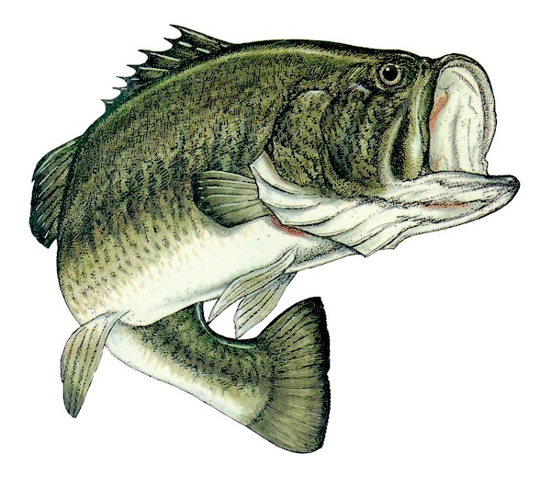
17th SEMI-ANNUAL
VICTORIA PARK KID’S
FISHING TOURNAMENT!

$200 IN CASH PRIZES!!

Open to all Victoria Park residents 15 years of age or younger!

Saturday, January 7, 2023 from 3 – 5 p.m.
Lake Victoria Park (dock and boat ramp)
$100 for the longest Largemouth Bass.
$25 for the second longest Largemouth Bass.
$25 for the longest “other species” fish (longest fish other than a Largemouth Bass).
$25 for longest fish caught fly fishing.
$25 for the most Mayan Cichlid’s & Armored Catfish caught and turned in.

- Fishing in Lake Victoria only, bring your own fishing equipment.
- All entrants must register at the dock before fishing, starting at 2:30 on the 7th.
- Catch and Release ONLY, all fish must be released alive (except Cichlids) to qualify.
- Open to Victoria Park residents (and children/grandchildren), 15 years or younger.
- All entrants must have a digital camera to record your catch,
I will provide official measuring device for photo w/fish.
- If you go in any kind of a boat, you must wear a life jacket!
- If you’re 10 years of age or under, you need a parent/guardian.
- All Fishing Regulations of the State of Florida shall pertain.
-Knot tying and Fly Casting lessons upon request for the kids!
- Feel free to give me a call if you have any questions.

Please help keep the lake and park area trash free and let’s have fun!

SPONSORED BY VICTORIA PARK REALTY SERVICE

